**SECTION A (60 Marks)**

Answer only **three** questions from this section.

1. Methanol can be produced from methane by a two steps process.

Step 1: CH4(g) + H2O(g)  CO(g) + 3H2(g)

Step 2: CO(g) + 2H2(g)  CH3OH(g)

1. Calculate the heat change for each step. Using the heats of combustion below. (04 marks)

|  |  |  |  |  |
| --- | --- | --- | --- | --- |
|  | CH4(g) | CO(g) | H2(g) | CH3OH(g) |
| ∆HᵒC [kJ/mol] | -808 | -283 | -245 | -671 |

1. Explain how changes in pressure and temperature effect the yield of products in each step. (05 marks)
2. State two advantages of operating the two steps in reaction vessels close to each other in an industry. (03 marks)
3. Hydrogen iodide decomposes when heated at a temperature of 450ᵒC according to the equation below. 2HI(g) H2(g) + I2(g)
4. Write an expression for equilibrium constant, Kc for the reaction. (0½ mark)
5. Describe an experiment to determine equilibrium constant, Kc for the reaction. (05 marks)
6. 3.24g of hydrogen iodide were heated in 800cm3 bulb. When equilibrium was attained, the bulb was cooled and broken under potassium iodide solution, and the mixture required 36cm3 of 0.2M sodium thiosulphate solution. Calculate the value of equilibrium constant, Kc for the reaction. (02½ marks)
7. Define the term first electron affinity. (01 mark)
8. The first electron affinities and atomic numbers of group (VII) elements are given in the table below.

|  |  |  |  |  |
| --- | --- | --- | --- | --- |
| Elements | 9F | 17Cl | 35Br | 53I |
| E.A [kJ/mol | -328 | -349 | -325 | -295 |

1. Plot a graph of electron affinity against atomic numbers of the elements. (03 marks)
2. Explain the shape of the graph. (03 marks)
3. Fluorine shows anomalous behavior from the rest of the elements. State three other reasons for the anomalous behavior of fluorine apart from electron affinity. (01½ marks)
4. Describe the reaction of:
5. Oxides of chlorine with sodium hydroxide solution. (04 marks)
6. Hydrides of group (VII) elements with concentrated sulphuric acid. (05 marks)
7. A solution containing chlorate (V) ions and dilute sulphuric acid was warm with iron (II) sulphate solution.
8. State what was observed. (01 mark)
9. Write equation for the reaction that took place. (01½ marks)
10. Write equations to show how the following conversions can be carried out. In each case indicate the reagents and conditions for the reactions.
11. Propanone to propan-1-ol (04 marks)
12. Benzene and propene to methoxybenzene (04½ marks)
13. Propan-1-ol to CH3CH(OH)CH2COOH (04 marks)
14.  (03 marks)
15.  (04½ marks)
16. Explain the following observations:
17. Propanone and trichloromethane are completely miscible liquids with evolution of heat. (04 marks)
18. When dilute sulphuric acid is added to copper (I) oxide, a reddish-brown solid and blue solution are formed. (03 marks)
19. Bromine rapidly substitutes in to the 2- or 4- positions in phenol but it slowly substitutes into 3-position in benzoic acid. (03 marks)
20. Hydrated sodium carbonate dissolves in water endothermically while anhydrous sodium carbonate dissolves in water exothermically. (03 marks)
21. An aqueous chromium (III) sulphate solution forms a green precipitate and bubbles of a colourless gas when a piece of magnesium ribbon is added to it. (05 marks)

**SECTION B (40 Marks)**

Answer only **two** questions from this section.

1. Explain what is meant by the following terms:
2. Solvent extraction. (01 mark)
3. Partition coefficient. (02 marks)
4. State:
5. Three conditions under which the partition law is invalid. (03 marks)
6. Describe an experiment to determine the partition coefficient of benzoic acid between ethoxyethane and water. (05 marks)
7. In an experiment to find the partition coefficient of ammonia between carbontetrachloride and water. 25.0cm3 of organic layer required 3.3cm3 of 0.1M nitric acid and 10cm3 of the aqueous layer required 13.2cm3 of 0.25M nitric acid for complete reaction. Determine the partition coefficient of ammonia between carbontetrachloride and water. (03 marks)
8. Nickel (II) ions reacts with excess ammonia to form a complex ion, [Ni(NH3)6]2+. 25.0cm3 of 1M ammonia solution were mixed with 25.0cm3 of aqueous nickel sulphate solution and the resultant solution, shaken with carbontetrachloride at room temperature. 25.0cm3 of the aqueous layer required 24.2cm3 of 0.5M nitric acid. Using your answer in (c) above, determine the concentration of nickel sulphate solution in mol/dm3. (06 marks)
9. Sodium, magnesium, silicon, phosphorous and sulphur are some of the elements of the periodic table.
10. Write the formula of the hydride of each element. (01½ marks)
11. Compare the reactivity of the hydrides of sodium, silicon and sulphur with water. (05 marks)
12. Write equations to show the reaction between:
13. Hydride of sulphur and acidified dichromate (VI) solution. (01½ marks)
14. Phosphorous hydride and borontrichloride. (01 mark)
15. The melting points of the chlorides of sodium, magnesium, silicon and sulphur 650ᵒC, -55ᵒC and -76ᵒC respectively.
16. Explain the trend in the melting points of the chlorides. (03 marks)
17. State what would be observed and write equation that took place between water and chloride of sulphur. (02½ marks)
18. 2.0g of impure sample of silicon (IV) chloride were shaken with water and the resultant solution made up to 250.0cm3. 25.0cm3 of the solution required 18.0cm3 of 0.2M sodium hydroxide solution. Calculate the percentage purity of silicon (IV) chloride. (04 marks)
19. Both propanal and propanone are carbonyl compounds.
20. Name a reagent that can be used to identify the functional group in both compounds. (01 mark)
21. State what is observed when the reagent you have named is treated with both compounds. (01 mark)
22. Write equation and outline the mechanism for the reaction between propanone and the reagent in a(i) above. (05 marks)
23. Propanal undergoes nucleophilic addition reactions while propene undergoes electrophilic addition reactions.
24. Distinquish between electrophilic and nucleophilic addition reaction. (02 marks)
25. Explain why propanal undergoes nucleophilic while propene undergoes electrophilic addition reactions. (03 marks)
26. Outline the mechanism for the reaction between: (@03 marks)
27. Propanal and sodium hydrogen sulphite.
28. Propene and chlorine water.
29. Write equations to show how propanal can be converted to propene. (02 marks)
30. Define the following terms: (@01 mark)
31. Cell constant. (ii). Electrolytic conductivity.
32. The resistance of a conductivity cell containing 0.25M barium chloride solution at 25ᵒC is 75.8Ω and the resistance of the same cell containing 0.03M sodium nitrated solution at 25ᵒC is 590Ω. Calculate the:
33. Electrolytic conductivity of barium chloride solution. (04 marks)
34. Molar conductivity of chloride ions in the solution. (03 marks)

[The electrolytic conductivity of 0.03M sodium nitrate solution at 25ᵒC is 4.56 x 10-3Ω-1/m and molar conductivity of barium ions is 2.43 x 10-5 Ω-1/m2/mol]

1. The table below shows the variation of electrolytic conductivity when 50.0cm3 of 0.1M sulphuric acid were titrated with sodium hydroxide solution.

|  |  |  |  |  |  |  |
| --- | --- | --- | --- | --- | --- | --- |
| Conductivity Ω-1/m | 3.40 | 2.30 | 1.20 | 0.80 | 1.60 | 2.50 |
| Volume of NaOH (cm3) | 1.0 | 3.0 | 5.0 | 7.0 | 9.0 | 11.0 |

1. Plot a graph of conductivity against volume of sodium hydroxide solution. (03 marks)
2. Explain the graph shape. (04 marks)
3. Calculate the concentration of sodium hydroxide solution in mol/dm3. (03 marks)
4. State two other applications of conductivity measurements. (01 mark)

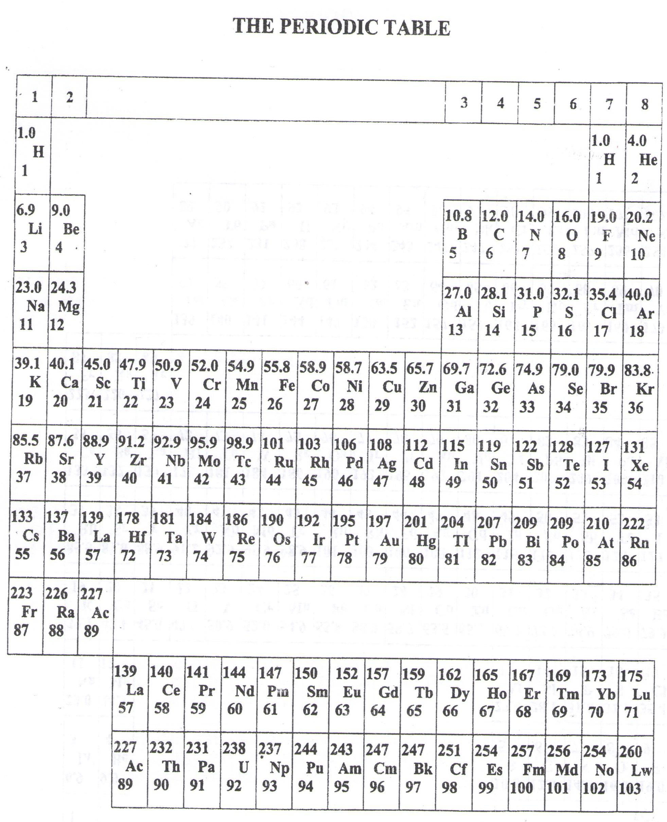

* ===END===

WELCOME TO SENIOR SIX, YEAR 2023

This is the last page of the printed paper, Page 06